## Recce Report – Quantock Hills

|  |
| --- |
| People |

|  |  |
| --- | --- |
| **Main contact:**  Monica Tilley  07948439113 | Monica was driving the main car during the production. |
| Secondary contact: James  07784697949 | James was driving the secondary car during the production. |

|  |
| --- |
| Transport/access |

Car access, drove by Monica Tilley and James Griffiths

|  |
| --- |
| Camera/sound |

There’s no power supply available to us anywhere at the location.

|  |
| --- |
| Food |

There isn’t any restaurant nearby which is why, before shooting, all crew members will have to resort to buying their own food at a local Tesco

|  |
| --- |
| Potential locations |

### Quantock Hills, Quantock Road.

|  |
| --- |
| Quantock Hills |

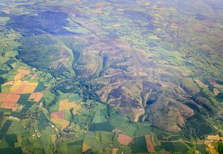

|  |
| --- |
| Transport/access |

Easy vehicle access to this location through Quantock Road.

|  |
| --- |
| Camera and lighting issues |

The shadow caused by the trees roadside will change the look in some of the shots even with colour correction.

|  |
| --- |
| Sound issues |

Incoming traffic and even aerial traffic could be an issue.