Advertising Essay

Moni Eve Tilley

Advertising Essay

Moni Eve Tilley

When watching adverts you always wonder what the strategies are in the videos, the three techniques are called Pathos, Logos and Ethos which each have different meanings makes each advert more interesting to watch when it shows up on their television screens. Mostly they are called the modes of persuasion.

They persuade the audience in a way to listen to what the advert is about. When a advert has a certain way of showing pity or sorrow it is Pathos which usually means the video is about a real situation with either a person, animal or object in a sad way.

If for instance an advert had facts that supported a product with evidence this would mean it is Logos because its persuading the audience to either use the product because it's good or not because of the evidence they show in these adverts.

In my point of view Ethos is the highly used persuasion because of who they use in their adverts like mostly celebrities that's what makes people watch the advert and enjoy the product more. It actually goes with the real meaning of Ethos, providing a understanding the importance of having a certain speaker to persuade and connect with audience.

    I had the chance of analysing a few adverts myself, I have one advert for each strategy.

The first on for Pathos is a Nike Advert called Henry's house, the setting for the video clearly shown in the title also means that it is around that person's house. You can also feel how energetic the video is with the music going on while he is running around the house kicking a ball. It makes you wanna go out and kick a ball around so the persuading strategy really works.

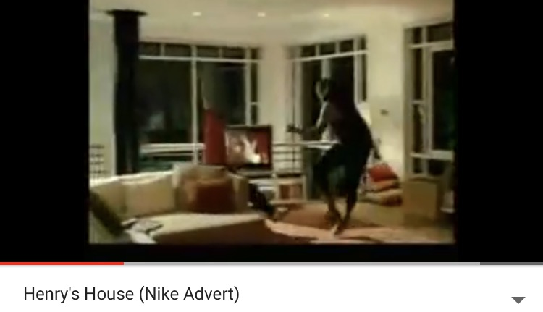

For a advert that has logos I had found a colgate toothpaste ad that showed three women commenting on how much the toothpaste had changed their teeth with very strange comments but it is there to be supporting evidence and also the dentist gives some interesting facts to persuade the audience to make them understand that it is a good product. 

The Jennifer Aniston advert for Emirate Airlines was a clever way to persuade the audience to use that certain airline, seeing how the celebrity enjoys the airline no matter which seat she sits in it shows both sides of the plane from Economy to normal it makes people wanna enjoy it just like she did. I like the friendship she evolves with the little boy and making the mum very happy it has humour in it also. 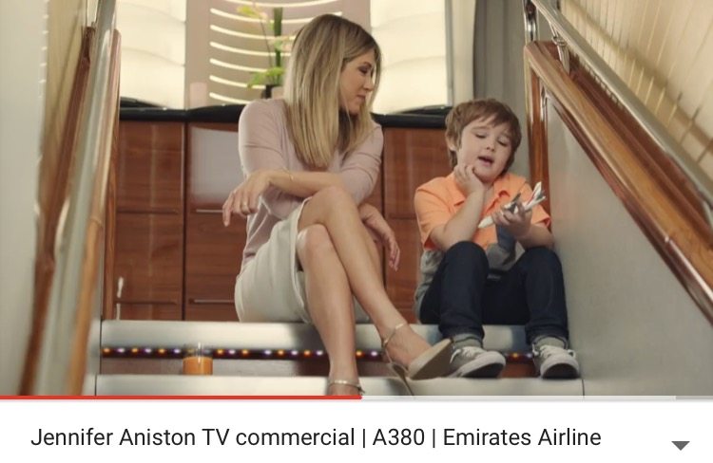

That's what makes every advert different.

When watching adverts you always wonder what the strategies are in the videos, the three techniques are called Pathos, Logos and Ethos which each have different meanings makes each advert more interesting to watch when it shows up on their television screens. Mostly they are called the modes of persuasion.

They persuade the audience in a way to listen to what the advert is about. When a advert has a certain way of showing pity or sorrow it is Pathos which usually means the video is about a real situation with either a person, animal or object in a sad way.

If for instance an advert had facts that supported a product with evidence this would mean it is Logos because its persuading the audience to either use the product because it's good or not because of the evidence they show in these adverts.

In my point of view Ethos is the highly used persuasion because of who they use in their adverts like mostly celebrities that's what makes people watch the advert and enjoy the product more. It actually goes with the real meaning of Ethos, providing a understanding the importance of having a certain speaker to persuade and connect with audience.

I had the chance of analysing a few adverts myself, I have one advert for each strategy.

The first on for Pathos is a Nike Advert called Henry's house, the setting for the video clearly shown in the title also means that it is around that person's house. You can also feel how energetic the video is with the music going on while he is running around the house kicking a ball. It makes you wanna go out and kick a ball around so the persuading strategy really works.

For a advert that has logos I had found a colgate toothpaste ad that showed three women commenting on how much the toothpaste had changed their teeth with very strange comments but it is there to be supporting evidence and also the dentist gives some interesting facts to persuade the audience to make them understand that it is a good product.

The Jennifer Aniston advert for Emirate Airlines was a clever way to persuade the audience to use that certain airline, seeing how the celebrity enjoys the airline no matter which seat she sits in it shows both sides of the plane from Economy to normal it makes people wanna enjoy it just like she did. I like the friendship she evolves with the little boy and making the mum very happy it has humour in it also.

That's what makes every advert different.